COSTUME NOTES FOR Penny and the Magic Medallion
Most cast members will wear their basic costume all the time (Except King and Bonidini). They will add pieces of clothing, belts or hats, etc., as their character is transformed in the story, but time is extremely short (less than a minute) so changes should be quick and easy to do.

SHOES:
Dark jazz shoes or ballet flats/dance shoes with long socks or tights – no exposed skin on legs. Other shoes may be acceptable depending on role – please have them approved by Becky! NO SNEAKERS! CAMPERS SHOULD BE ABLE TO DANCE EASILY AND SAFELY IN THEIR SHOES! Campers should start wearing their costume shoes as soon as possible to get accustomed to moving on stage with them.

Hark: | - Brightly colored peasant style blouse or shirt/tunic with belt over tights or knickers (can be loose long pants rolled up to knee with rubber band inside)  - Add jacket and/or hat for transformation | 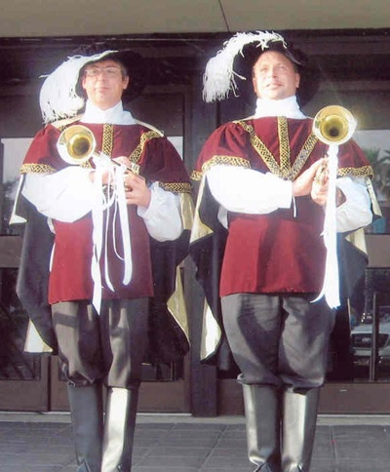  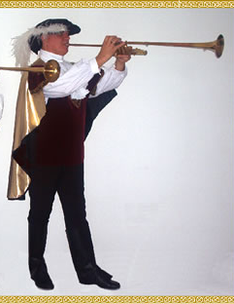
Simon: | - similar peasant clothes  - add tunic or armor of some type  for transformation  - Sword or staff | 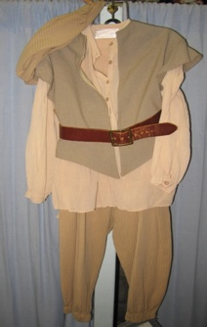  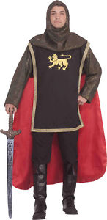
Queen: | - A “royal” dress or a long skirt - add sash, cape, crown or tiara for transformation | 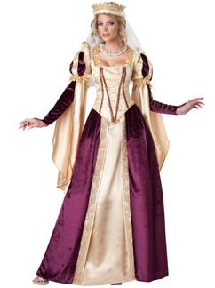
Cook: | - Dark skirt and peasant blouse or full shirt  - A wrinkled apron and a pressed apron  - a bandana or scarf which can be changed to a bonnet | 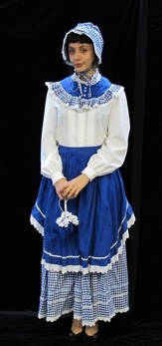
King: | - Typical King attire – lacy or full shirt, tunic, knickers, cloak, crown  - sword | 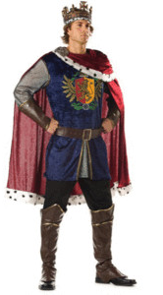  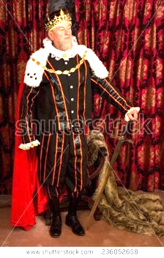
Penny: | - Modern style blouse and skirt  - Add jacket/blazer, fake glasses, white gloves (?) etc. for transformation  - Pull hair up or back for transformation
Bonibini | – may be especially colorful – scarves, hat, etc.  - peasant style clothes – perhaps bright colors (unique style – almost jester like)  Possible hat for Bonidini | 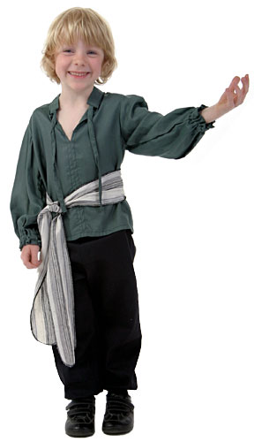

NOTE:
Hair must be held firmly OUT OF ALL ACTORS’ FACES. Girls should have their hair pulled back into a bun at the neck (Or pinned/clipped back if not long enough for a bun). Boys – low ponytail, pin sides as necessary to keep hair in place. USE PRODUCT TO KEEP HAIR OUT OF FACES

MAKE-UP:
Make up should be minimal BUT IS REQUIRED FOR ALL – EVEN BOYS. The actors are children and we want them to look like children – so keep it light!
Use light, natural colored lipstick, light blush, eye liner (bottom lid mainly) – no more. Eye shadow etc., is not required and should be barely visible if used.

NOTE: COSTUMES are to be approved by Monday and in house by Tuesday. Costumes and props are not to be removed from the theatre after Tuesday, until after the completion of the show on Friday.

If you would like to rent/buy a costume, here are some suggestions for places to check:
Party City  5600 Urbana Pike  Frederick, MD  (301) 695-0111 | Amazon  (order soon to be sure it arrives in time for the show) | Thrift stores or Goodwill, etc.

